**DATA MODDELING**

1. **ER diagram**

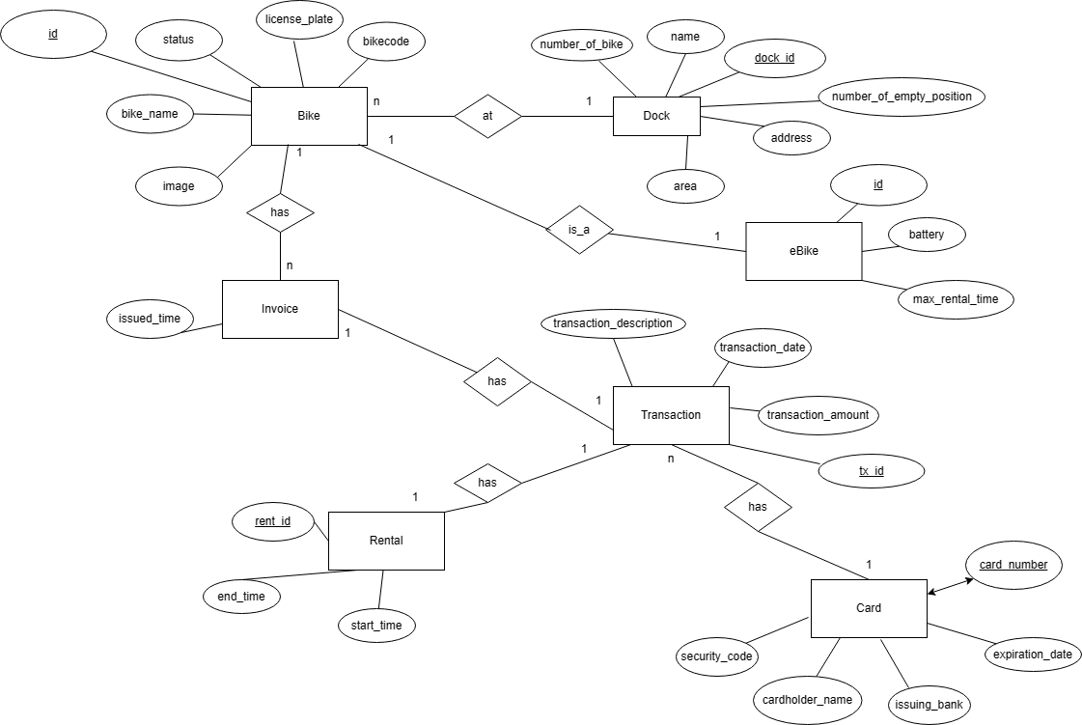

1. **Database design**
   1. **Logical data model**

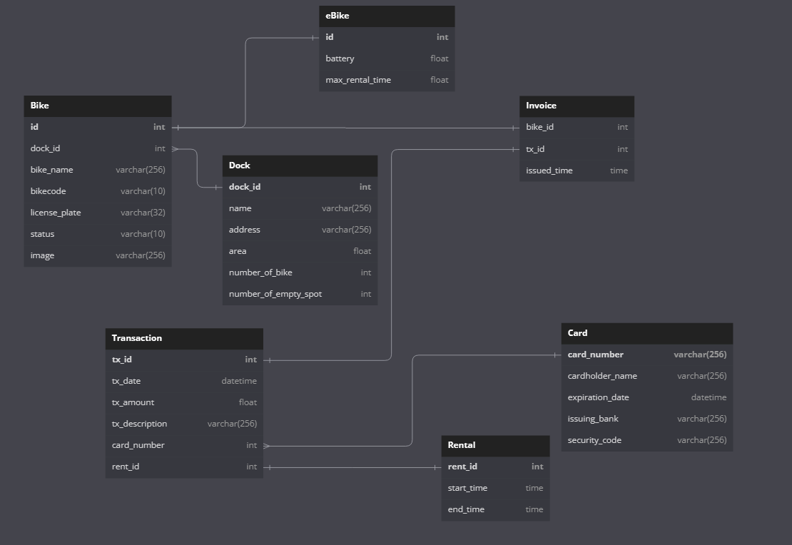

* 1. **Physical data model**

***Dock***

| **No.** | **PK** | **FK** | **Name** | **Data type** | **Mandatory** | **Description** |
| --- | --- | --- | --- | --- | --- | --- |
| 1 | x |  | dock_id | int | x | ID of dock |
| 2 |  |  | name | varchar(256) | x | Name of the dock |
| 3 |  |  | address | varchar(256) | x | Address of the dock |
| 4 |  |  | area | float |  | Area of the dock |
| 5 |  |  | num_of_bike | int | x | Number of current available bike in dock |
| 6 |  |  | num_of_empty_spot | int | x | Number of current available bike slot in dock for returning bike |

***Bike***

| **No.** | **PK** | **FK** | **Name** | **Data type** | **Mandatory** | **Description** |
| --- | --- | --- | --- | --- | --- | --- |
| 1 | x |  | id | int | x | ID of the bike |
| 2 |  | x | dock_id | int | x | ID of the dock |
| 3 |  |  | bike_name | varchar(256) | x | Name of the bike |
| 4 |  |  | lisence_plate | varchar(32) |  | License plate of the bike |
| 5 |  |  | bike_code | varchar(32) | x | Barcode of the bike |
| 6 |  |  | status | varchar(10) | x | Available/rented |
| 7 |  |  | image | varchar(256) |  | Path to image of the bike |

***eBike***

| **No.** | **PK** | **FK** | **Name** | **Data type** | **Mandatory** | **Description** |
| --- | --- | --- | --- | --- | --- | --- |
| 1 | x | x | id | int | x | ID of the invoice |
| 2 |  |  | battery | float | x | Current battery of the bike |
| 3 |  |  | max_rental_time | float | x | Time bike can go with current battery |

***Invoice***

| **No.** | **PK** | **FK** | **Name** | **Data type** | **Mandatory** | **Description** |
| --- | --- | --- | --- | --- | --- | --- |
| 1 |  | x | bike_id | int | x | ID of the invoice |
| 2 | x | x | transaction_id | int | x | ID of the transaction |
| 3 |  |  | issued_time | DateTime | x | String representation of the time that the invoice is issued |

***Card***

| **No.** | **PK** | **FK** | **Name** | **Data type** | **Mandatory** | **Description** |
| --- | --- | --- | --- | --- | --- | --- |
| 1 | x |  | card_number | varchar(256) | x | Number of the card |
| 2 |  |  | cardholder_name | varchar(256) | x | Name of cardholder |
| 3 |  |  | expiration_date | datetime | x | Expiration date of the card |
| 4 |  |  | issuing_bank | varchar(256) | x | Issuing bank of the card |
| 5 |  |  | security_code | varchar(256) | x | Security code |

***Transaction***

| **No.** | **PK** | **FK** | **Name** | **Data type** | **Mandatory** | **Description** |
| --- | --- | --- | --- | --- | --- | --- |
| 1 | x |  | transaction_id | int | x | ID of transaction |
| 2 |  |  | transaction_date | datetime | x | Time the transaction is made |
| 3 |  |  | transaction_amount | float | x | The amount of money for the transaction |
| 4 |  |  | transaction_desciption | varchar(256) |  | The content of the transaction |
| 5 |  | x | rent_id | int | x | ID of |

***Rental***

| **No.** | **PK** | **FK** | **Name** | **Data type** | **Mandatory** | **Description** |
| --- | --- | --- | --- | --- | --- | --- |
| 1 | x |  | rent_id | int | x | ID of the rental |
| 2 |  |  | start_time | time | x | Time start renting |
| 3 |  |  | end_time | time |  | Time end renting (null if the bike is currently being rented) |

* 1. **Database script**

Create table Bike(

id int primary key,

dock_id int NOT NULL FOREIGN KEY REFERENCES Dock(dock_id),

bike_name varchar(256),

bike_code varchar(10),

license_plate varchar(32),

status varchar(10),

image varchar(256)

)

Create table Dock (

dock_id int primary key,

name varchar(256),

address varchar(256) NOT NULL,

area float,

number_of_bike int,

number_of_empty_spot int

)

Create table eBike (

id int primary key,

battery int NOT NULL,

max_rental_time float,

FOREIGN KEY id REFERENCES Bike(id)

)

Create table Invoice (

bike_id int NOT NULL FOREIGN KEY REFERENCES Bike(id),

tx_id int NOT NULL FOREIGN KEY REFERENCES Transaction(tx_id),

issued_time Datetime NOT NULL,

)

Create table Transaction (

tx_id int primary key,

tx_date Datetime,

tx_description varchar(256),

tx_amount float NOT NULL,

rent_id int NOT NULL FOREIGN KEY REFERENCES Rental(rent_id),

card_number int NOT NULL FOREIGN KEY REFERENCES Card(card_number)

)

Create table Rental (

rent_id int primary key,

start_time Datetime NOT NULL,

end_time Datetime NOT NULL

)

Create table Card (

card_number int primary key,

cardholder_name varchar(256) NOT NULL,

expiration_date Datetime,

issuing_bank varchar(256) NOT NULL,

security_code varchar(256)

)